**Battle of Neighborhood Project Report**

1. **Introduction**

X is a software company and their customer company Y is based in New York organizing event. Company X and Y deal with a project and currently work on a this project to organize an event for 5 days for a group of developers from all over the world. Company Y has determine to a program including, hotels, hall of meetings, places for visiting, places for shopping, restaurants, cafes etc. Company Y has to show the list of places in New York to attendees, including cafes, restaurants, hall of meetings, hotels etc. It has provide a map in case attendee can't use here mobile application for any reason.

1. **Data Selection**

The data used in this project is provided by Forsquare location data. The data grouped by landscape area, and each included the information about this area and all information about restaurants, cafes, and stores in which this area.

1. **Methodology**

For this report I used a few different maps that could help a new investor to decide the best neighborhood to open a restaurant in Toronto based on it's income, population and available competitors. In order to do that I've used the 2016 Census information combined with choropleth maps to visually display the wealthier and more populational neighborhoods and Foursquare data to display the current restaurants in each region.

1. **Results**

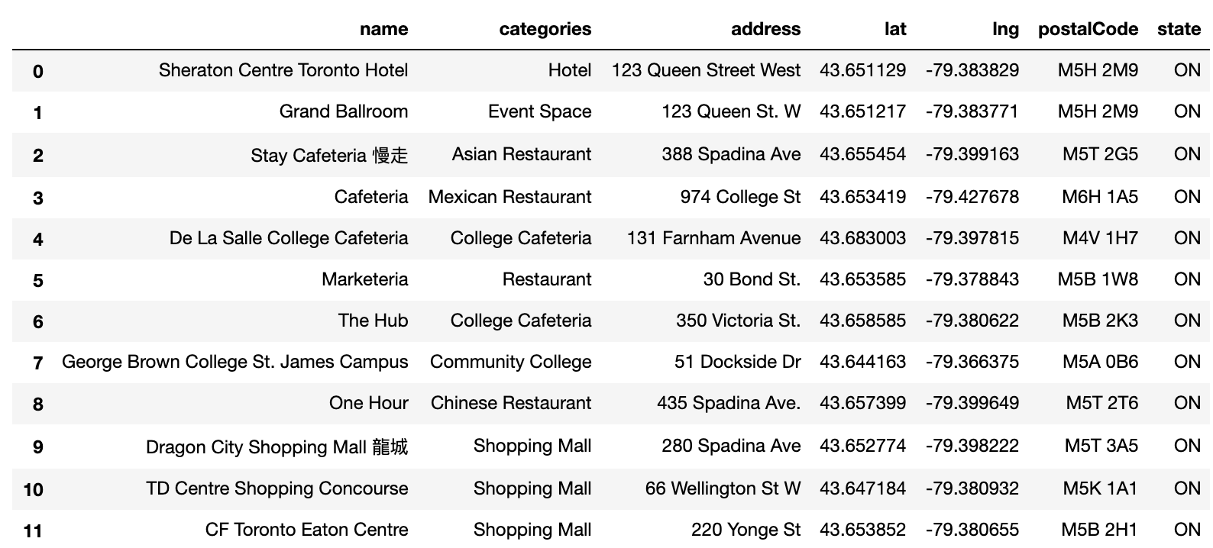

***Figure 1***

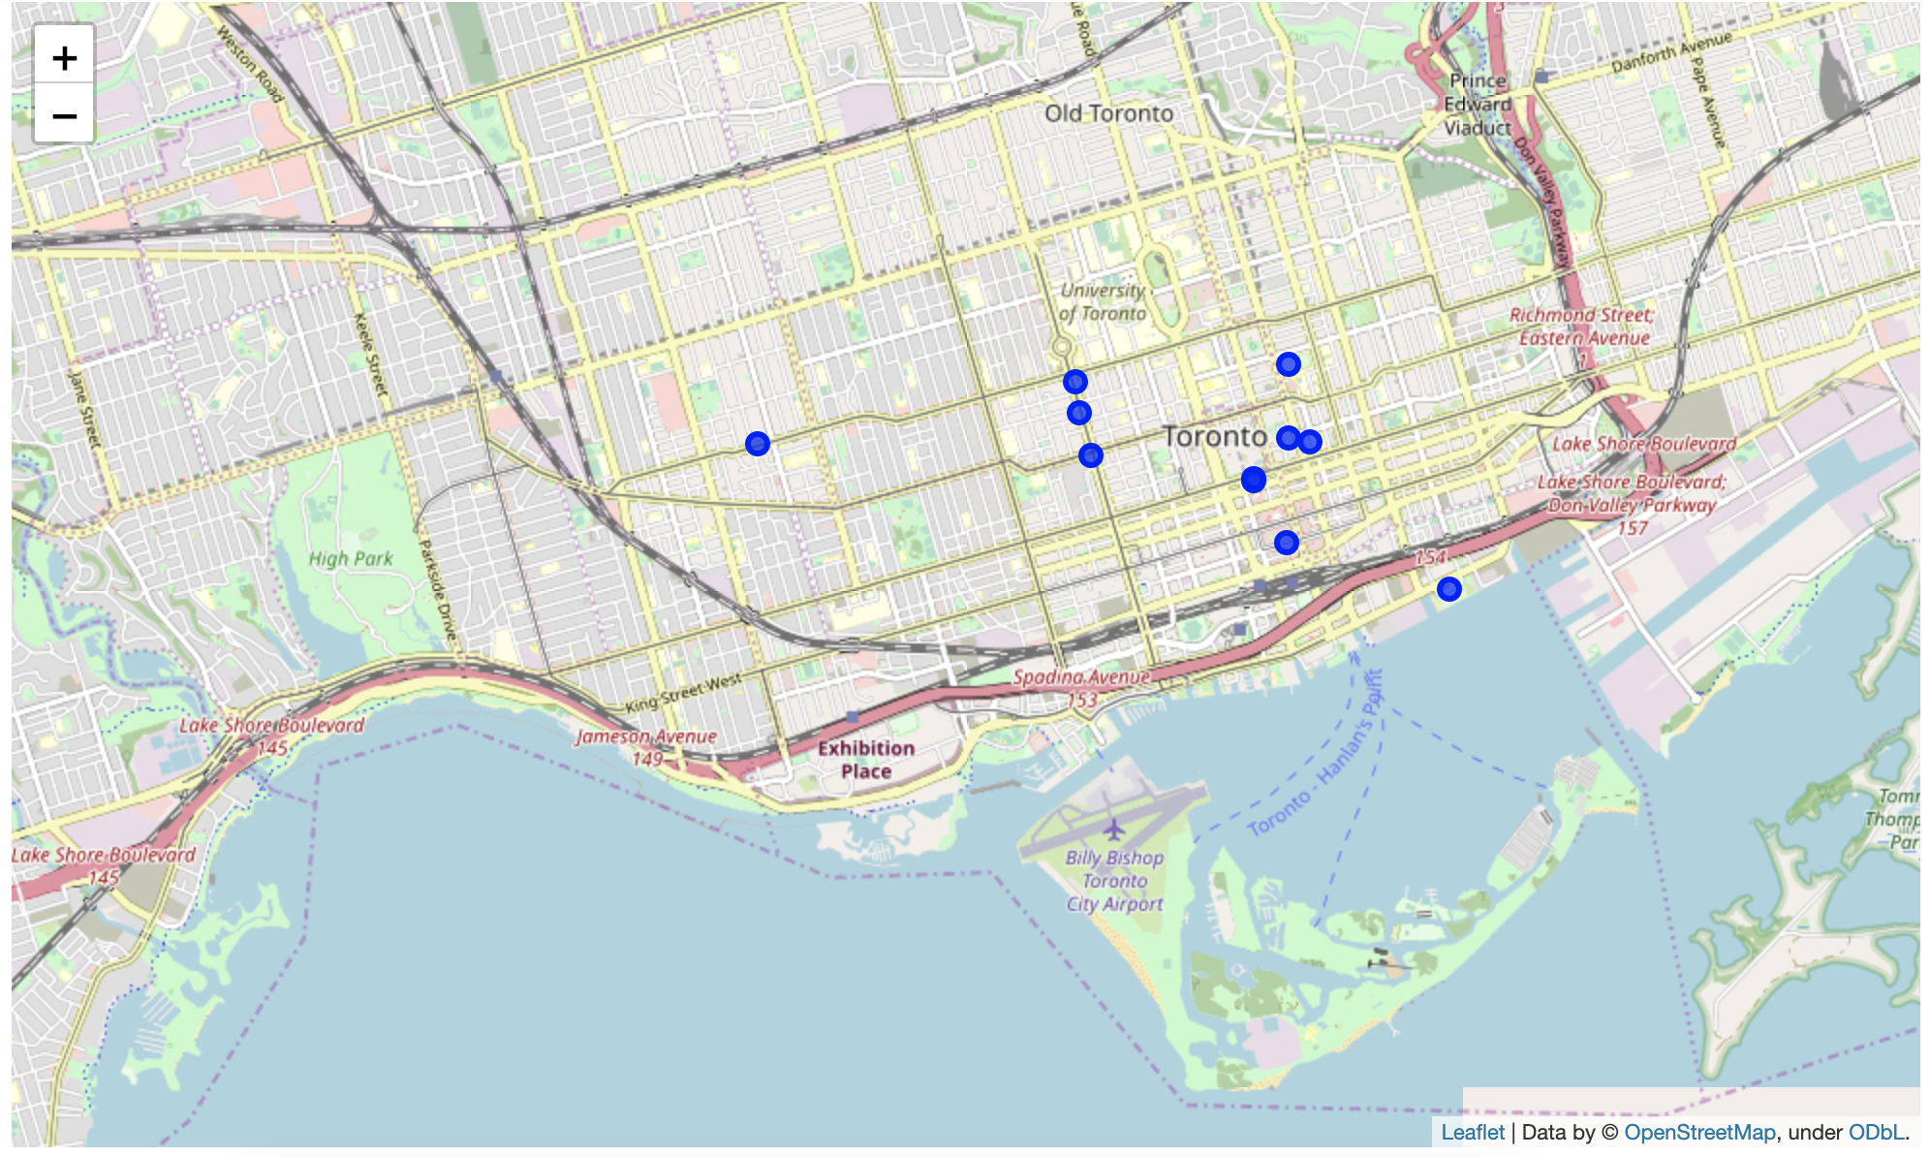

**Figure 2**

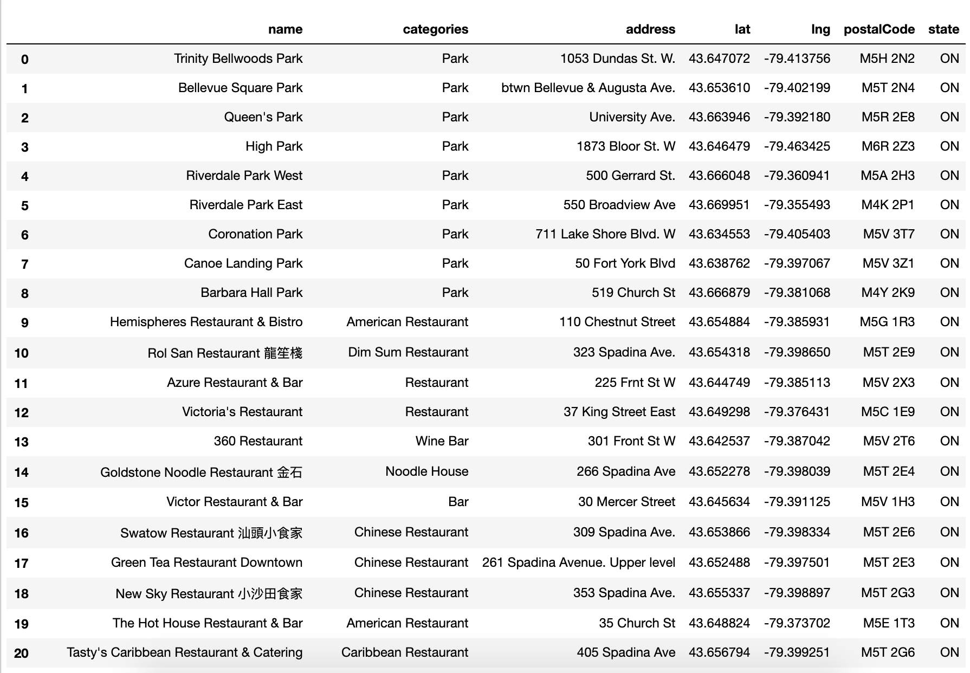

**Figure 3**

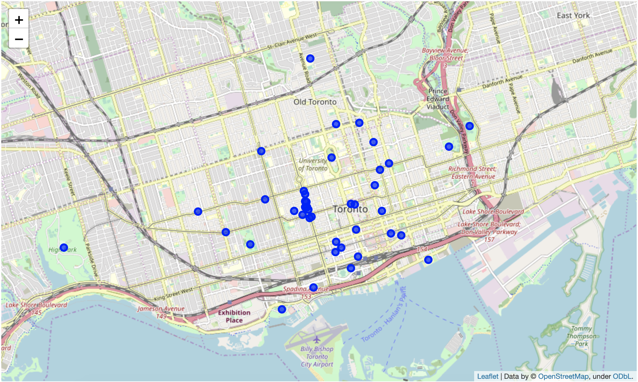

**Figure 4**

1. **Discussion**

In general, while ll of these tools are usefull, there is nothing like visiting the actual city, seeing the neighborhoods, and speaking with residents. If it’s possible, an in person visit is highly recommended before making a big move

1. **Conclusion**

Although all of goals of this Project were met there is definitely room for further improvement and development as noted below. However, the goals of the project met and, with some more work, could easily be developed into a full phledged application that could support the openning business idea in an unknown location.

As per the neighborhood or restaurant type mentioned like places analysis can be checked. A venue with lowest risk and competition can be identified.